DOKUZ EYLUL UNIVERSITY
ENGINEERING FACULTY
DEPARTMENT OF COMPUTER ENGINEERING

CME1251 PROJECT BASED LEARNING – I
FINAL REPORT
PROJECT – I

THE BATTLESHIP GAME

by
Alperen AYDIN
Arda ASLANER
Bedirhan KARAAHMETLI

Lecturers
Asst.Prof. Özlem AKTAŞ
Res.Asst. İlker KALAYCI

IZMIR
11.4.2021

CHAPTER ONE
PROGRESS DESCRIPTION
• The Battleship Game is a strategy game.
• The game is played on a 12*30 game field.
• Player choose 3 coordinates for triangle battleship.
• The selected coordinates are displayed on the screen.
• Console displays ship info.
• Computer makes a random shoot.
• If the battleship survives, the player gets points equal to the area of the battleship.
• If the user's score is sufficient, it will be listed in the high score table.

CHAPTER TWO
TASK SUMMARY

Completed Tasks
• Alperen AYDIN designing and printing the playing field. Also checking the validity of the entered triangle. Finally, make the game playeable with all its rules. Editing codes.
• Arda ASLANER searching and printing simple properties of a triangle. Randomly shooting and display it in the coordinate plane. Finally, designing the menu. Editing codes.
•Bedirhan KARAAHMETLI obtaining the coordinates of the ship from the user and printing the ship to the playing field. Calculating and printing of advanced properties of triangle. Finally, making the high score table operations and remaining parts of the game. Editing codes.

Incomplete Tasks: Reasons and Explanations
• All problems have been fixed, there is no incomplete task.

Additional Improvements to the Project

•User interface improvements have been made.
•Wrong input errors were printed on the screen and the game was prevented from crashing.
•Access to ship properties listing and shooting screen is blocked without receiving ship input.
•The replayability of the game has been provided.

CHAPTER THREE
EXPLANATION of algorıthms

Screenshots
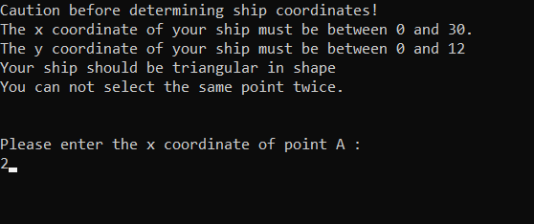
Figure 3.1 Taking coordinates from player
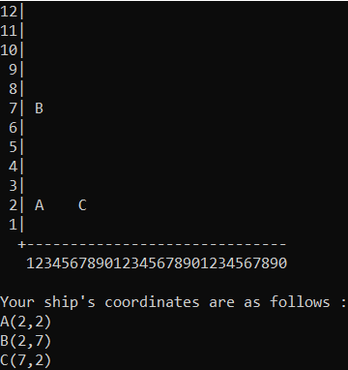
Figure 3.2 Printing the ship

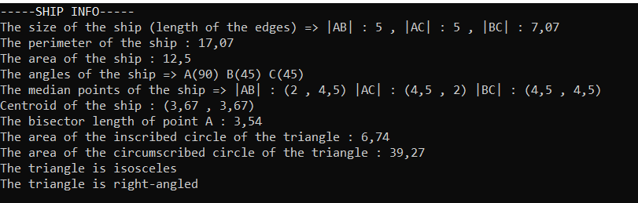
Figure 3.3 Listing the ship’s info

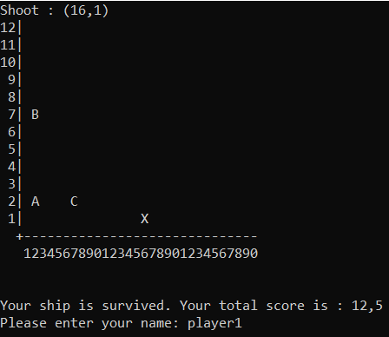
Figure 3.4 Shooting
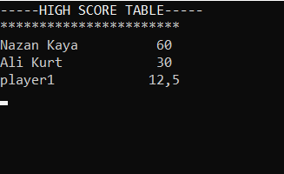
Figure 3.5 High Score Table
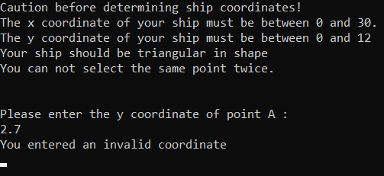
Figure 3.6 Invalid inputs
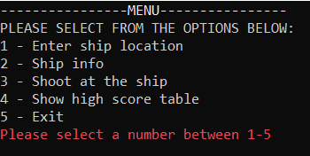
Figure 3.7 Invalid inputs

Functions
• Using setcursorposition function
• Math library
• Try-parse method
• Random

Algorithms and Solution Strategies
• Designing the menu and adding functionality using the do-while loop.
• Determining the type of triangle by comparing the side lengths of the triangle
• Using "try-parse" to prevent invalid entries from failing and displaying the necessary error messages to the player.

CHAPTER FOUR
PROBLEMS ENCOUNTERED
- • Fixed compatibility issue between Windows and Mac devices.
- • The problem of closing the game due to invalid input has been resolved.
- • Fixed shifts in the highscore table.

CHAPTER FIVE
conclusıon
- • In this project, we designed a warship strategy game that can be played on console. At the start of the game, the coordinates of the triangular warship are requested from the user. The ship is placed on the playground. The characteristics of the ship were listed and the ship was randomly shot. Made a system of earning points if the ship survives.

REFERENCES
• How to use tryparse method from :
https://docs.microsoft.com/tr-tr/dotnet/api/system.int32.tryparse?view=net-5.0

• https://proofwiki.org/wiki/Length_of_Angle_Bisector

• Triangle properties info from:
https://byjus.com/maths/triangles/

• https://docs.microsoft.com/en-us/dotnet/csharp/programming-guide/

• https://en.wikipedia.org/wiki/Main_Page

• https://www.geeksforgeeks.org/console-class-in-c-sharp/

AppendIx A
Poster of the Project
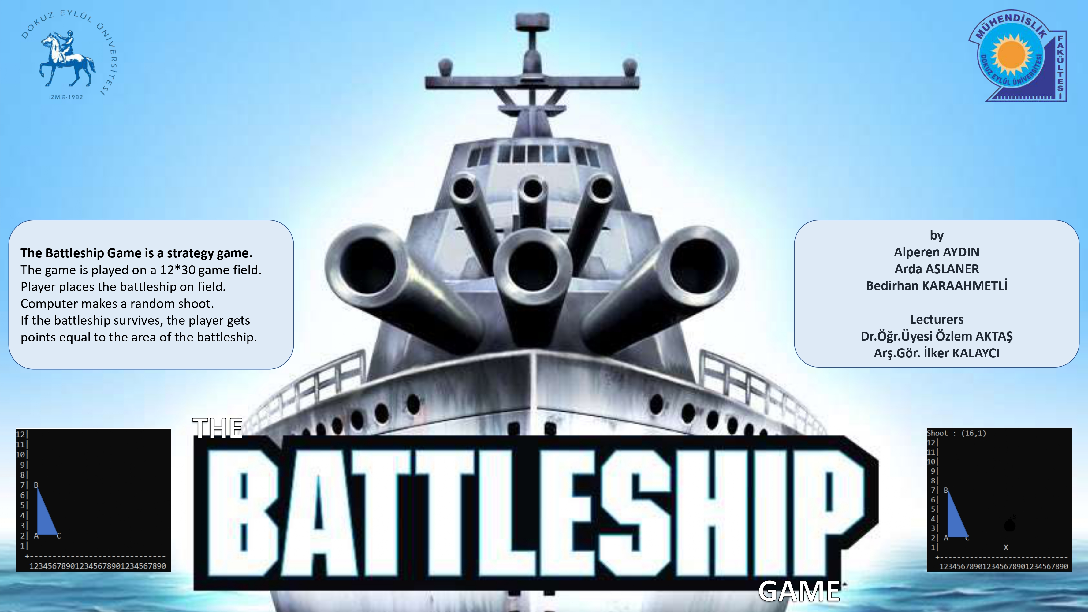
Figure A.1 Poster.

AppendIx B
Code of the Project
//Taking coordinates from user

Console.WriteLine("Caution before determining ship coordinates!");
Console.WriteLine("The x coordinate of your ship must be between 0 and 30.");
Console.WriteLine("The y coordinate of your ship must be between 0 and 12");
Console.WriteLine("Your ship should be triangular in shape");
Console.WriteLine("You can not select the same point twice.");
Console.WriteLine("");
Console.WriteLine("");
Console.WriteLine("Please enter the x coordinate of point A :");
xA = Console.ReadLine();
if (!(int.TryParse(xA, out number))) //Invalid input check
{
Console.WriteLine("You entered an invalid coordinate");
Console.ReadLine();
Console.Clear();
xA = null;
break;
}

//Displaying menu and selecting an option

Console.WriteLine("\x1b[1m----------------MENU----------------\x1b[0m
\nPLEASE SELECT FROM THE OPTIONS BELOW:\n1 - Enter ship location\n2 - Ship info\n3 - Shoot at the ship\n4 – Show high score table\n5 – Exit ");

string choosing0 = Console.ReadLine();

while (choosing0 != "1" && choosing0 != "2" && choosing0 != "3" && choosing0 != "4" && choosing0 != "5")
{
Console.Clear();
Console.WriteLine("\x1b[1m----------------MENU----------------\x1b[0m\nPLEASE SELECT FROM THE OPTIONS BELOW:\n1 - Enter ship location\n2 - Ship info\n3 - Shoot at the ship\n4 – Show high score table\n5 – Exit ");
Console.ForegroundColor = ConsoleColor.Red;
Console.WriteLine("Please select a number between 1-5");
Console.ForegroundColor = ConsoleColor.White;
choosing0 = Console.ReadLine();
Console.Clear();
}
int choosing = Convert.ToInt32(choosing0);

// Creating Cartesian coordinate system and placing the points

Console.WriteLine("12|\n11|\n10|\n 9|\n 8|\n 7|\n 6|\n 5|\n 4|\n 3|\n 2|\n 1|\n +
------------------------------\n 123456789012345678901234567890 \n \n \n");

Console.SetCursorPosition(Convert.ToInt32(xA) + 2, 12 - Convert.ToInt32(yA));
Console.WriteLine("A");

Console.SetCursorPosition(Convert.ToInt32(xB) + 2, 12 - Convert.ToInt32(yB));
Console.WriteLine("B");

Console.SetCursorPosition(Convert.ToInt32(xC) + 2, 12 - Convert.ToInt32(yC));
Console.WriteLine("C");

//Checking if the ship survived from the random shot

if (areaOfTheShip == ImageArea)
{
Console.WriteLine("Your ship sank! Total score is 0!");
}
else
{
score = areaOfTheShip;
Console.WriteLine("Your ship is survived.
Your total score is : " + areaOfTheShip);
Console.Write("Please enter your name: ");
name = Console.ReadLine();
}

//Displaying high-score table

Console.WriteLine("\x1b[1m--------HIGH SCORE TABLE--------\x1b[0m");
Console.WriteLine("********************************");
Console.WriteLine("\x1b[1mName Score\x1b[0m");

if (score <= 10)
{
Console.WriteLine("Nazan Kaya 60\nAli Kurt 30\nSibel Arslan 10");
}

if (score > 10 && score <= 30)
{
Console.WriteLine("Nazan Kaya 60\nAli Kurt 30\n" + name);
Console.SetCursorPosition(27, 5);
Console.Write(score);
}

if (score > 30 && score <= 60)
{
Console.WriteLine("Nazan Kaya 60\n" + name);
Console.SetCursorPosition(27, 4);
Console.Write(score);
Console.WriteLine("\nAli Kurt 30");
}

if (score > 60)
{
Console.WriteLine(name);
Console.SetCursorPosition(27, 3);
Console.Write(score);
Console.WriteLine("\nNazan Kaya 60\nAli Kurt 30");
}

